**JavaScript Tutorial: Math Object In JavaScript | Web Development Tutorials #61**

**JavaScript Tutorial- Math Object in JavaScript**

In this tutorial, we are going to see different *Math* objects used in JavaScript. These are important for them who want to use different mathematical functions in their browser. This function allows us to perform mathematical tasks on numbers.

Make a new file as *tut61.html* and add the boilerplate to get the HTML template. Then give the title as **Math Object** under the <title> tag. If we write the following code under the <script> tag, then we will get the list of all those *Math* functions that are used in JavaScript.

let m = Math;

console.log(m)

Copy

Let us now print the values of some constants using the **Math**functions.

// Printing the constants from Math Object

console.log("The value of Math.E is ", Math.E)

console.log("The value of Math.PI is ", Math.PI)

console.log("The value of Math.LN2 is ", Math.LN2)

console.log("The value of Math.SQRT1_2 is ", Math.SQRT1_2)

console.log("The value of Math.LOG2E is ", Math.LOG2E)

Copy

After executing the above JavaScript code, we will see the values of these constants in the output as follows-

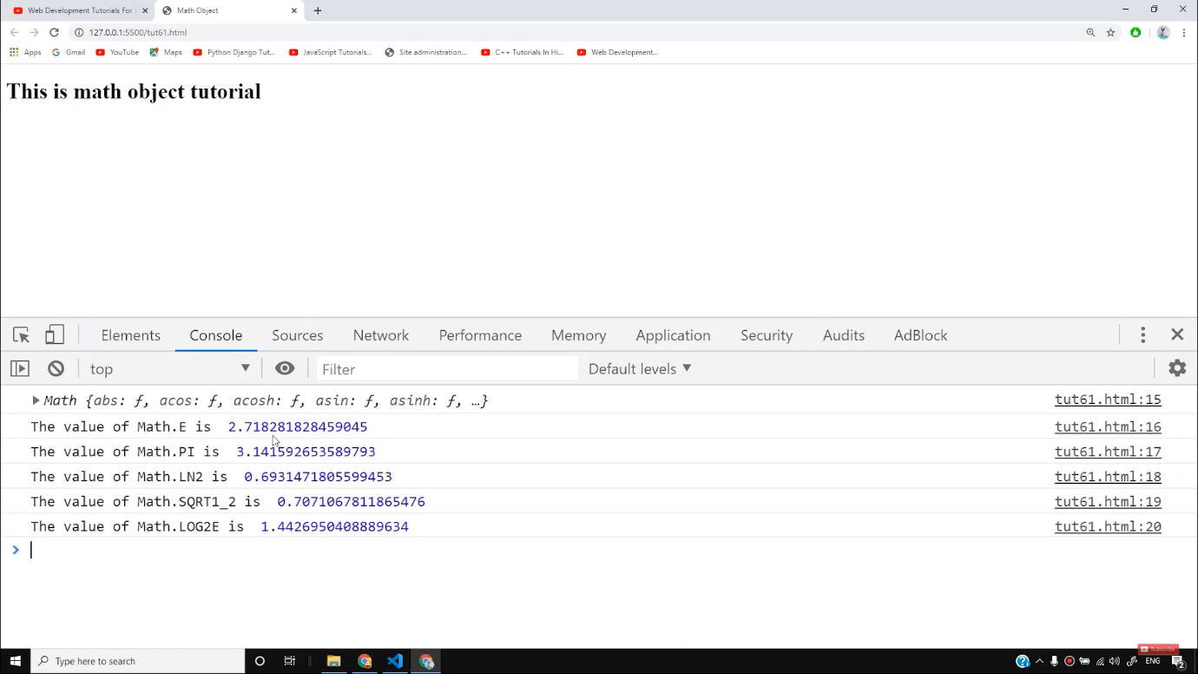

Now let us see how to print the functions with the help of Math Object. Here we will initialize two variables and then call them under different functions as follows-

let a = 34.64534;

let b = 89;

console.log("The value of a and b is ", a, b);

console.log("The value of a and b rounded is ", Math.round(a), Math.round(b));

Copy

The output we get, is as follows-

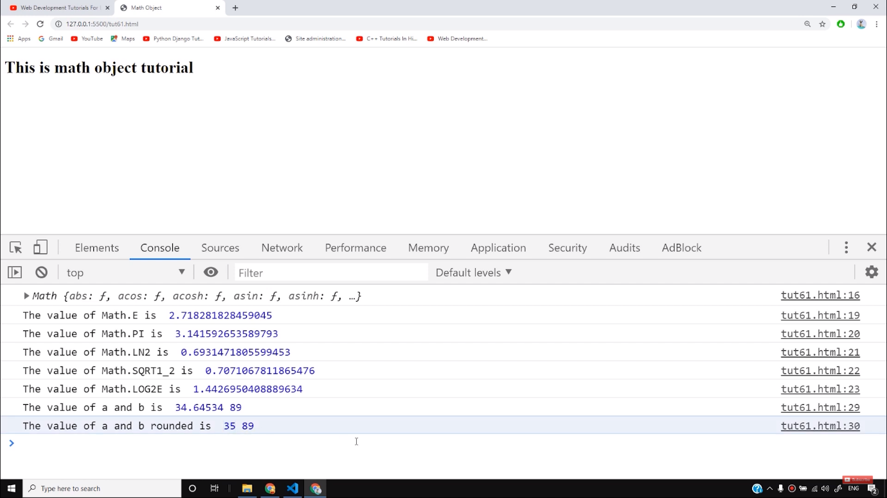

*Math.round*is used to round the values to the nearest integer. Then there are ***Math.pow(****)* and ***Math.sqrt()*** functions that are used to return the power and square root of any number respectively. There are other functions like **ceil**and **floor.**Ceil is used to round up the number to the nearest integer whereas floor is used to round down to the nearest integer.

console.log("5.8 rounded up to nearest integer is ", Math.ceil(5.8))

console.log("5.8 rounded down to nearest integer is ", Math.floor(5.8))

Copy

In the above example, 5.8 is rounded up and rounded down as follows-

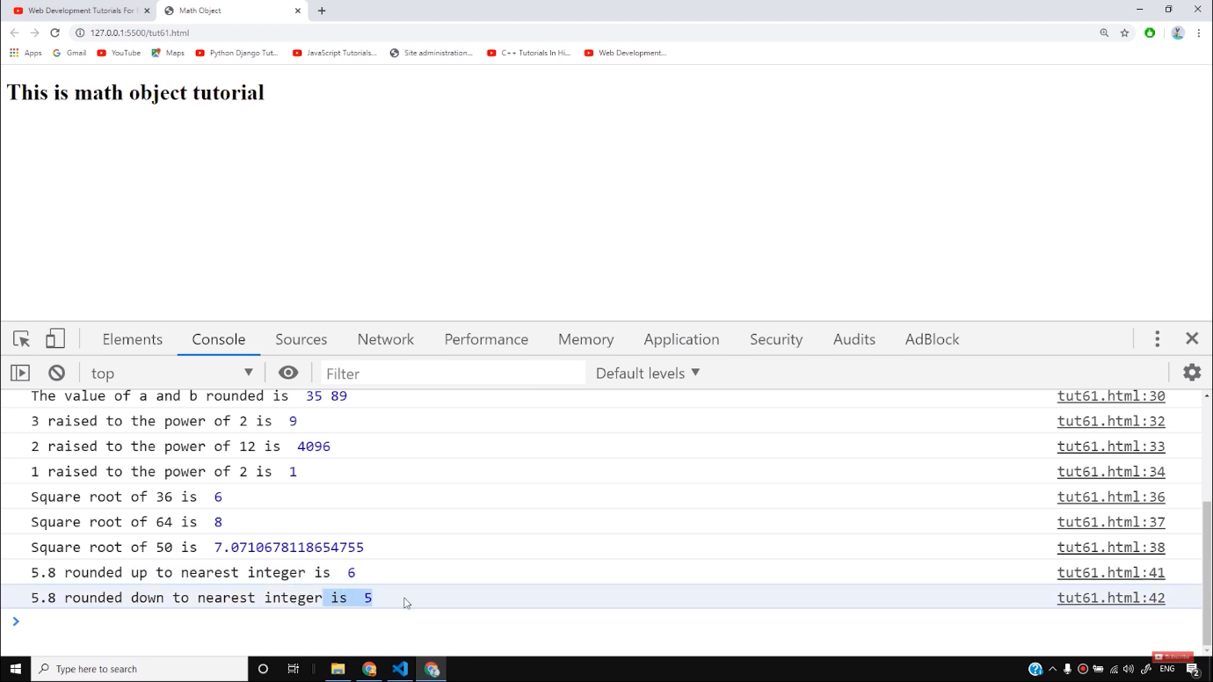

Now let us see some trignometric functions. The values given here will be in *radians*as follows-

// Trinonometric Functions

console.log("The value of sin(pi) is ", Math.sin(Math.PI/2))

console.log("The value of tan(pi) is ", Math.tan(Math.PI/2))

console.log("The value of cos(pi) is ", Math.cos(Math.PI/2))

Copy

The output of the following code will be as follows-

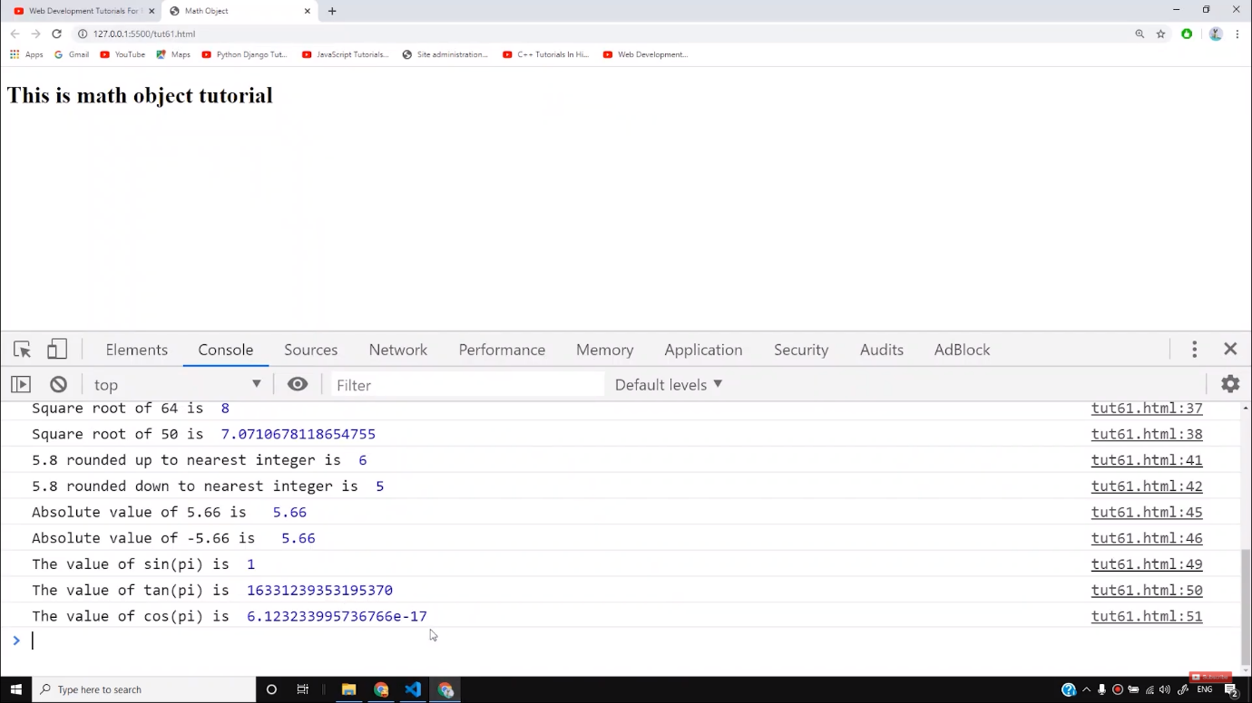

We can take the help of *min* and *max*functions to find the minimum and maximum numbers respectively.

console.log("Minimum value of 4, 5, 6 is ", Math.min(4,5, 6));

console.log("Maximum value of 4, 5, 6 is ", Math.max(4,5, 6));

Copy

This code will return the minimum and maximum number between 4, 5, and 6.

Let us now see how to generate random numbers in JavaScript. We use *Math.random()*to generate any random number as follows-

let r = Math.random();

console.log("The random number is ", r)

Copy

It will generate any random number between 0-1 as follows-

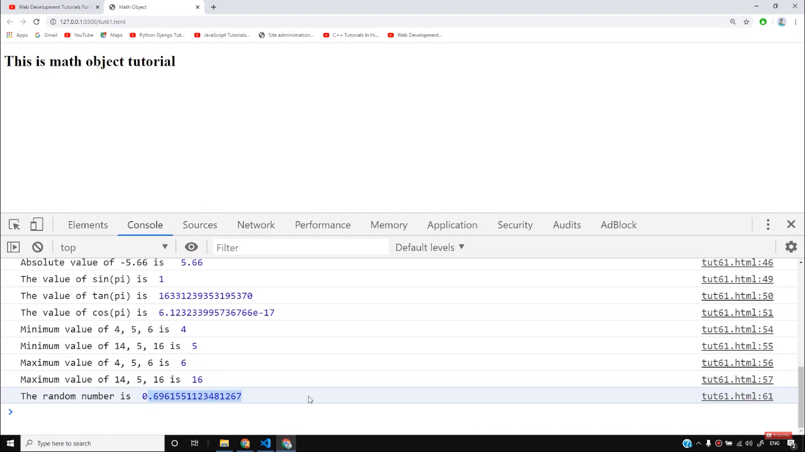

But to generate a random number between**a**and **b,**we can use this particular formula and write as follows-

let a1 = 50;

let b1 = 60;

let r50_60 = a1 + (b1-a1)*Math.random();

console.log("The random number is ", r50_60)

Copy

It will generate the random number between 50 and 60.

This was all about different Math functions and you can use these functions to account with any mathematical related issues on your website. You can learn more by practicing.

**Code as described/written in the video**

<!DOCTYPE html>

<html lang="en">

<head>

<meta charset="UTF-8">

<meta name="viewport" content="width=device-width, initial-scale=1.0">

<meta http-equiv="X-UA-Compatible" content="ie=edge">

<title>Math Object</title>

</head>

<body>

<div class="container">

<h1>This is math object tutorial</h1>

</div>

<script>

// Printing the Math Object

let m = Math;

console.log(m)

// Printing the constants from Math Object

console.log("The value of Math.E is ", Math.E)

console.log("The value of Math.PI is ", Math.PI)

console.log("The value of Math.LN2 is ", Math.LN2)

console.log("The value of Math.SQRT1_2 is ", Math.SQRT1_2)

console.log("The value of Math.LOG2E is ", Math.LOG2E)

// Printing the Functions from Math Object

let a = 34.64534;

let b = 89;

console.log("The value of a and b is ", a, b);

console.log("The value of a and b rounded is ", Math.round(a), Math.round(b));

console.log("3 raised to the power of 2 is ", Math.pow(3, 2))

console.log("2 raised to the power of 12 is ", Math.pow(2, 12))

console.log("1 raised to the power of 2 is ", Math.pow(1, 2))

console.log("Square root of 36 is ", Math.sqrt(36))

console.log("Square root of 64 is ", Math.sqrt(64))

console.log("Square root of 50 is ", Math.sqrt(50))

// Ceil and floor

console.log("5.8 rounded up to nearest integer is ", Math.ceil(5.8))

console.log("5.8 rounded down to nearest integer is ", Math.floor(5.8))

// Abs function

console.log("Absolute value of 5.66 is ", Math.abs(5.66))

console.log("Absolute value of -5.66 is ", Math.abs(-5.66))

// Trinonometric Functions

console.log("The value of sin(pi) is ", Math.sin(Math.PI/2))

console.log("The value of tan(pi) is ", Math.tan(Math.PI/2))

console.log("The value of cos(pi) is ", Math.cos(Math.PI/2))

// Min and max functions

console.log("Minimum value of 4, 5, 6 is ", Math.min(4,5, 6));

console.log("Minimum value of 14, 5, 16 is ", Math.min(14,5, 16));

console.log("Maximum value of 4, 5, 6 is ", Math.max(4,5, 6));

console.log("Maximum value of 14, 5, 16 is ", Math.max(14,5, 16));

// Generating a random number

let r = Math.random();

// Random number b/w (a, b) = a + (b-a)*Math.random()

let a1 = 50;

let b1 = 60;

let r50_60 = a1 + (b1-a1)*Math.random();

console.log("The random number is ", r)

console.log("The random number is ", r50_60)

</script>

</body>

</html>

# JavaScript Math Object

[❮ Previous](https://www.w3schools.com/js/js_date_methods_set.asp)[Next ❯](https://www.w3schools.com/js/js_random.asp)

The JavaScript Math object allows you to perform mathematical tasks on numbers.

### **Example**

Math.PI;

[Try it Yourself »](https://www.w3schools.com/js/tryit.asp?filename=tryjs_math_pi)

## **The Math Object**

Unlike other objects, the Math object has no constructor.

The Math object is static.

All methods and properties can be used without creating a Math object first.

## **Math Properties (Constants)**

The syntax for any Math property is : Math.*property*.

JavaScript provides 8 mathematical constants that can be accessed as Math properties:

### **Example**

Math.E        // returns Euler's number  
Math.PI       // returns PI  
Math.SQRT2    // returns the square root of 2  
Math.SQRT1_2  // returns the square root of 1/2  
Math.LN2      // returns the natural logarithm of 2  
Math.LN10     // returns the natural logarithm of 10  
Math.LOG2E    // returns base 2 logarithm of E  
Math.LOG10E   // returns base 10 logarithm of E

[Try it Yourself »](https://www.w3schools.com/js/tryit.asp?filename=tryjs_math_constants)

## **Math Methods**

The syntax for Math any methods is : Math.*method*(*number*)

## **Number to Integer**

There are 4 common methods to round a number to an integer:

|  |
| --- |
|  |
| Math.round(x) | Returns x rounded to its nearest integer |
|  |  |
| Math.ceil(x) | Returns x rounded up to its nearest integer |
|  |  |
| Math.floor(x) | Returns x rounded down to its nearest integer |
|  |  |
| Math.trunc(x) | Returns the integer part of x ([new in ES6](https://www.w3schools.com/js/js_es6.asp)) |

## **Math.round()**

Math.round(x) returns the nearest integer:

### **Examples**

Math.round(4.6);

[Try it Yourself »](https://www.w3schools.com/js/tryit.asp?filename=tryjs_math_round_1)

Math.round(4.5);

[Try it Yourself »](https://www.w3schools.com/js/tryit.asp?filename=tryjs_math_round)

Math.round(4.4);

[Try it Yourself »](https://www.w3schools.com/js/tryit.asp?filename=tryjs_math_round_2)

## **Math.ceil()**

Math.ceil(x) returns the value of x rounded **up** to its nearest integer:

### **Example**

Math.ceil(4.9);  
Math.ceil(4.7);  
Math.ceil(4.4);  
Math.ceil(4.2);  
Math.ceil(-4.2);

[Try it Yourself »](https://www.w3schools.com/js/tryit.asp?filename=tryjs_math_ceil)

## **Math.floor()**

Math.floor(x) returns the value of x rounded **down** to its nearest integer:

### **Example**

Math.floor(4.9);  
Math.floor(4.7);  
Math.floor(4.4);  
Math.floor(4.2);  
Math.floor(-4.2);

[Try it Yourself »](https://www.w3schools.com/js/tryit.asp?filename=tryjs_math_floor)

## **Math.trunc()**

Math.trunc(x) returns the integer part of x:

### **Example**

Math.trunc(4.9);  
Math.trunc(4.7);  
Math.trunc(4.4);  
Math.trunc(4.2);  
Math.trunc(-4.2);

[Try it Yourself »](https://www.w3schools.com/js/tryit.asp?filename=tryjs_math_trunc)

## **Math.sign()**

Math.sign(x) returns if x is negative, null or positive:

### **Example**

Math.sign(-4);  
Math.sign(0);  
Math.sign(4);

[Try it Yourself »](https://www.w3schools.com/js/tryit.asp?filename=tryjs_math_sign)

Math.trunc() and Math.sign() were added to [JavaScript 2015 - ES6](https://www.w3schools.com/js/js_es6.asp).

ADVERTISEMENT

## **Math.pow()**

Math.pow(x, y) returns the value of x to the power of y:

### **Example**

Math.pow(8, 2);

[Try it Yourself »](https://www.w3schools.com/js/tryit.asp?filename=tryjs_math_pow)

## **Math.sqrt()**

Math.sqrt(x) returns the square root of x:

### **Example**

Math.sqrt(64);

[Try it Yourself »](https://www.w3schools.com/js/tryit.asp?filename=tryjs_math_sqrt)

## **Math.abs()**

Math.abs(x) returns the absolute (positive) value of x:

### **Example**

Math.abs(-4.7);

[Try it Yourself »](https://www.w3schools.com/js/tryit.asp?filename=tryjs_math_abs)

## **Math.sin()**

Math.sin(x) returns the sine (a value between -1 and 1) of the angle x (given in radians).

If you want to use degrees instead of radians, you have to convert degrees to radians:

Angle in radians = Angle in degrees x PI / 180.

### **Example**

Math.sin(90 * Math.PI / 180);     // returns 1 (the sine of 90 degrees)

[Try it Yourself »](https://www.w3schools.com/js/tryit.asp?filename=tryjs_math_sin)

## **Math.cos()**

Math.cos(x) returns the cosine (a value between -1 and 1) of the angle x (given in radians).

If you want to use degrees instead of radians, you have to convert degrees to radians:

Angle in radians = Angle in degrees x PI / 180.

### **Example**

Math.cos(0 * Math.PI / 180);     // returns 1 (the cos of 0 degrees)

[Try it Yourself »](https://www.w3schools.com/js/tryit.asp?filename=tryjs_math_cos)

## **Math.min() and Math.max()**

Math.min() and Math.max() can be used to find the lowest or highest value in a list of arguments:

### **Example**

Math.min(0, 150, 30, 20, -8, -200);

[Try it Yourself »](https://www.w3schools.com/js/tryit.asp?filename=tryjs_math_min)

### **Example**

Math.max(0, 150, 30, 20, -8, -200);

[Try it Yourself »](https://www.w3schools.com/js/tryit.asp?filename=tryjs_math_max)

## **Math.random()**

Math.random() returns a random number between 0 (inclusive), and 1 (exclusive):

### **Example**

Math.random();

[Try it Yourself »](https://www.w3schools.com/js/tryit.asp?filename=tryjs_math_random)

You will learn more about Math.random() in the next chapter of this tutorial.

## **The Math.log() Method**

Math.log(x) returns the natural logarithm of x.

The natural logarithm returns the time needed to reach a certain level of growth:

### **Examples**

Math.log(1);

[Try it Yourself »](https://www.w3schools.com/js/tryit.asp?filename=tryjs_math_log)

Math.log(2);

[Try it Yourself »](https://www.w3schools.com/js/tryit.asp?filename=tryjs_math_log_2)

Math.log(3);

[Try it Yourself »](https://www.w3schools.com/js/tryit.asp?filename=tryjs_math_log_3)

Math.E and Math.log() are twins.

How many times must we multiply Math.E to get 10?

Math.log(10);

[Try it Yourself »](https://www.w3schools.com/js/tryit.asp?filename=tryjs_math_log_ten_times)

## **The Math.log2() Method**

Math.log2(x) returns the base 2 logarithm of x.

How many times must we multiply 2 to get 8?

Math.log2(8);

[Try it Yourself »](https://www.w3schools.com/js/tryit.asp?filename=tryjs_math_log2)

## **The Math.log10() Method**

Math.log10(x) returns the base 10 logarithm of x.

How many times must we multiply 10 to get 1000?

Math.log10(1000);

[Try it Yourself »](https://www.w3schools.com/js/tryit.asp?filename=tryjs_math_log10)

## **JavaScript Math Methods**

|  |  |
| --- | --- |
| **Method** | **Description** |
| [abs(x)](https://www.w3schools.com/jsref/jsref_abs.asp) | Returns the absolute value of x |
| [acos(x)](https://www.w3schools.com/jsref/jsref_acos.asp) | Returns the arccosine of x, in radians |
| [acosh(x)](https://www.w3schools.com/jsref/jsref_acosh.asp) | Returns the hyperbolic arccosine of x |
| [asin(x)](https://www.w3schools.com/jsref/jsref_asin.asp) | Returns the arcsine of x, in radians |
| [asinh(x)](https://www.w3schools.com/jsref/jsref_asinh.asp) | Returns the hyperbolic arcsine of x |
| [atan(x)](https://www.w3schools.com/jsref/jsref_atan.asp) | Returns the arctangent of x as a numeric value between -PI/2 and PI/2 radians |
| [atan2(y, x)](https://www.w3schools.com/jsref/jsref_atan2.asp) | Returns the arctangent of the quotient of its arguments |
| [atanh(x)](https://www.w3schools.com/jsref/jsref_atanh.asp) | Returns the hyperbolic arctangent of x |
| [cbrt(x)](https://www.w3schools.com/jsref/jsref_cbrt.asp) | Returns the cubic root of x |
| [ceil(x)](https://www.w3schools.com/jsref/jsref_ceil.asp) | Returns x, rounded upwards to the nearest integer |
| [cos(x)](https://www.w3schools.com/jsref/jsref_cos.asp) | Returns the cosine of x (x is in radians) |
| [cosh(x)](https://www.w3schools.com/jsref/jsref_cosh.asp) | Returns the hyperbolic cosine of x |
| [exp(x)](https://www.w3schools.com/jsref/jsref_exp.asp) | Returns the value of Ex |
| [floor(x)](https://www.w3schools.com/jsref/jsref_floor.asp) | Returns x, rounded downwards to the nearest integer |
| [log(x)](https://www.w3schools.com/jsref/jsref_log.asp) | Returns the natural logarithm (base E) of x |
| [max(x, y, z, ..., n)](https://www.w3schools.com/jsref/jsref_max.asp) | Returns the number with the highest value |
| [min(x, y, z, ..., n)](https://www.w3schools.com/jsref/jsref_min.asp) | Returns the number with the lowest value |
| [pow(x, y)](https://www.w3schools.com/jsref/jsref_pow.asp) | Returns the value of x to the power of y |
| [random()](https://www.w3schools.com/jsref/jsref_random.asp) | Returns a random number between 0 and 1 |
| [round(x)](https://www.w3schools.com/jsref/jsref_round.asp) | Rounds x to the nearest integer |
| [sign(x)](https://www.w3schools.com/jsref/jsref_sign.asp) | Returns if x is negative, null or positive (-1, 0, 1) |
| [sin(x)](https://www.w3schools.com/jsref/jsref_sin.asp) | Returns the sine of x (x is in radians) |
| [sinh(x)](https://www.w3schools.com/jsref/jsref_sinh.asp) | Returns the hyperbolic sine of x |
| [sqrt(x)](https://www.w3schools.com/jsref/jsref_sqrt.asp) | Returns the square root of x |
| [tan(x)](https://www.w3schools.com/jsref/jsref_tan.asp) | Returns the tangent of an angle |
| [tanh(x)](https://www.w3schools.com/jsref/jsref_tanh.asp) | Returns the hyperbolic tangent of a number |
| [trunc(x)](https://www.w3schools.com/jsref/jsref_trunc.asp) | Returns the integer part of a number (x) |